**K. Load Regulation using Zener diode**

**Aim:**

**Calculate load regulation, record values and calculate the percentage load regulation of the zener diode**

**Apparatus Required: PSpice**

ORCAD / Capture CIS

**Circuit Diagram**



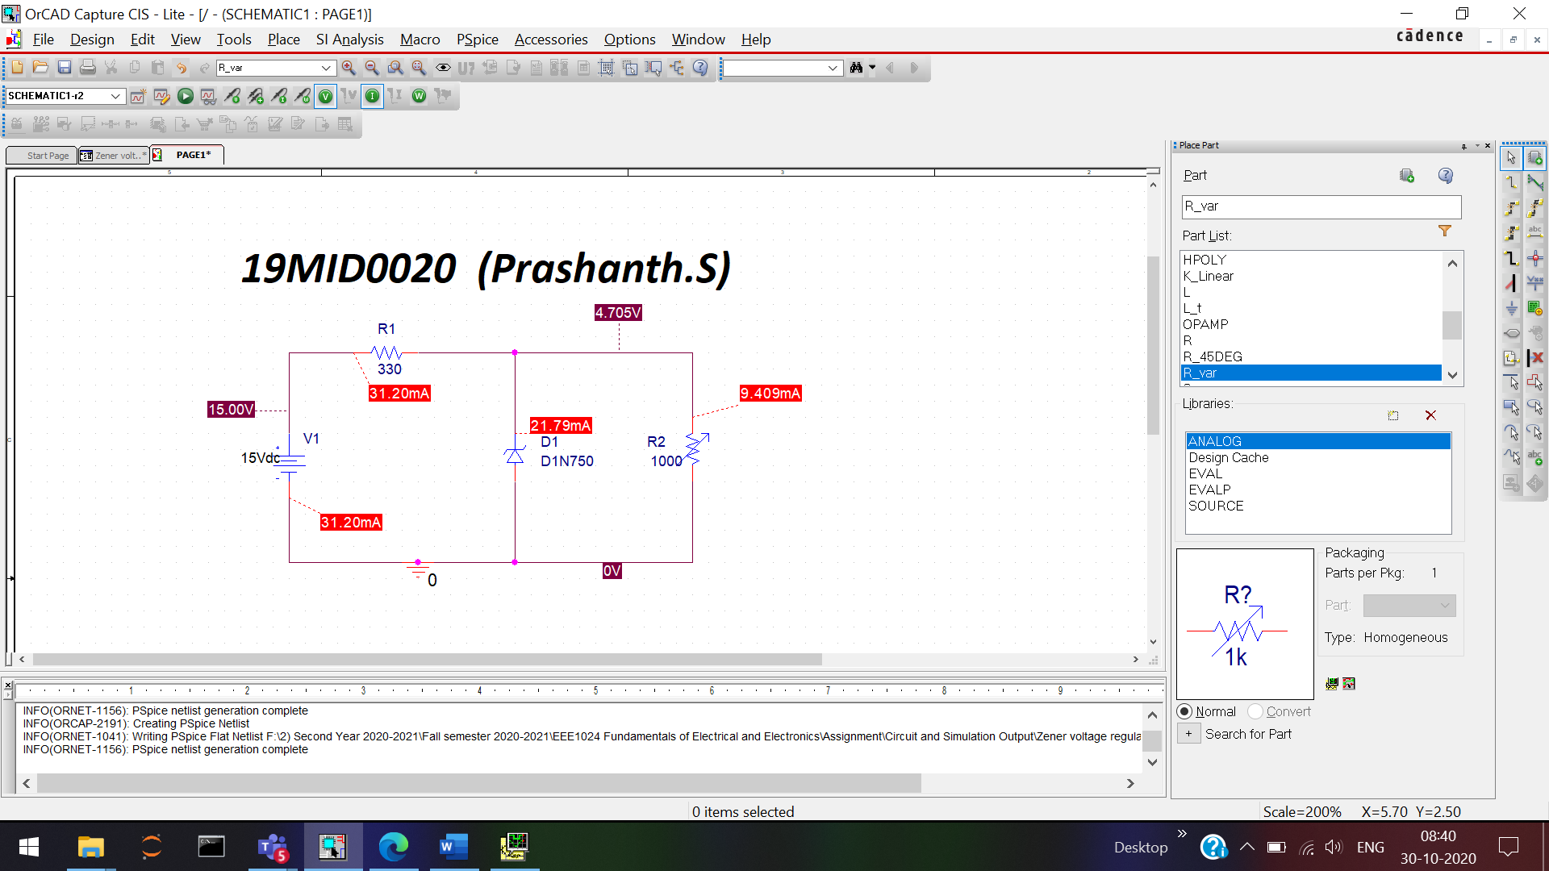

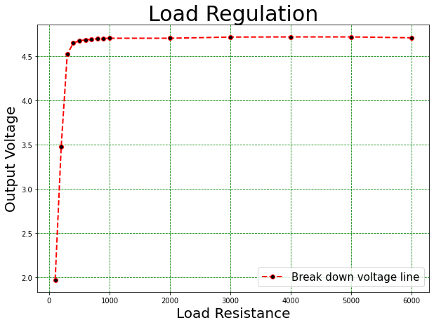

**Table (i) Load Regulation:**

|  |  |  |
| --- | --- | --- |
| **Sl.No** | **Load Resistance in ohms** | **Output DC Voltage (VL) in Volts** |
| **1** | **100** | **1.974** |
| **2** | **200** | **3.482** |
| **3** | **300** | **4.523** |
| **4** | **400** | **4.651** |
| **5** | **500** | **4.675** |
| **6** | **600** | **4.687** |
| **7** | **700** | **4.694** |
| **8** | **800** | **4.699** |
| **9** | **900** | **4.702** |
| **10** | **1000** | **4.705** |
| **11** | **2000** | 4.705 |
| **12** | **3000** | **4.718** |
| **13** | **4000** | **4.720** |
| **14** | **5000** | **4.720** |
| **15** | **6000** | **4.71** |

**Percentage Load Regulation**

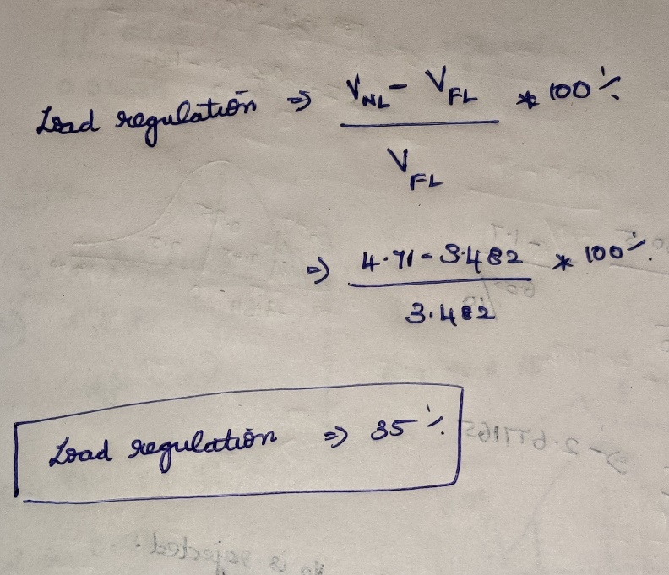

**Result:** The Voltage regulation application of Zener diode is understood and proved using OrCAD Pspice Software.

**Inference:** The **Zener diode**, with its accurate and specific reverse **breakdown voltage**, allows for a simple, inexpensive **voltage** regulator. Combined with the right resistor, fine control over both the **voltage** and the supply current can be attained.

**Reg. No: 19MID0020 Name:Prashanth.S Date: 30.10.2020**